
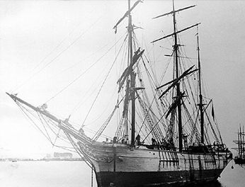
Acadian Driftwood
#5
The Band

From the album

‘Northern Lights, Southern Cross’

Capital Records

Vocabulary and Translations!

- rendezvous –

- pull up your stakes –

- ill-content –

- walkin’ in chains –

- omen –

- turf –

- Sais tu, Acadie j’ai le mal du pays –

Do You Know It?

Places to know and map:

- Saint Pierre
- Plains of Abraham
- New Orleans
- The part of Canada that was called Acadia

There are various words that refer to “homelessness” in the song. Find one.

Where does the narrator say he has some “kin” (family)?

In the third stanza, what three different places does the narrator mentions Acadians ended up?

Did You Catch It?

35

Do You Get It?

- What war was over?

- What part of Acadia was “south of the border”? (today these Acadians are called “Cajuns”)

- What treaty was signed and who signed it?

- Why did people along the coast say, “You better keep movin’ on”?

- The Acadian deportation began in 1755. There is a historical error in the first stanza. Can you find it?

- Where was the “motherland”?

- There are several examples of figurative language: (line 2: hills were smokin’, line 6: slowly sinking to their rendezvous, line 13, 14: Acadian driftwood, gypsy tail wind, line 40: the government has us walking in chains, line 49: set my compass north, I got winter in my blood). Select one phrase and explain the meaning of the figurative language.

- Lines 7-11 describe an enemy. Who were the enemies? Who viewed them as the enemy?
Why did they end up the enemy?

Activities and Extensions!

Compare how Evangeline felt in the poem, “Evangeline” to this narrator’s feelings.
Find out when the Acadians came to Canada, and what their lives were like in the early years.
In stanza four, the narrator talks about people moving to new lands and being accepted. How does this tie into immigration policies we see in Canada today?



Teacher’s Guide

BACKGROUND INFORMATION

When fighting between Britain and France began again in 1755, the British tried to force the Acadians to take the same oath of allegiance that other British subjects took. The Acadians continued to argue that they should be neutral. But they were French-speaking, and the British were not sure they could be trusted, so the British decided to remove them. That summer and fall of 1755, British troops rounded up over 7000 Acadians. In every Acadian community around the Bay of Fundy, the soldiers burned Acadian homes and herded Acadian prisoners onto ships, which carried them off to the American colonies, from Massachusetts south to Georgia. The big Acadian families became hopelessly separated. Many Acadians died during the deportation. Some fled to French territory or hid in the woods, but many of these fugitives were seized in the next few years. The British continued to deport Acadians until 1762. The Acadian farmlands were given to settlers from Britain and New England.

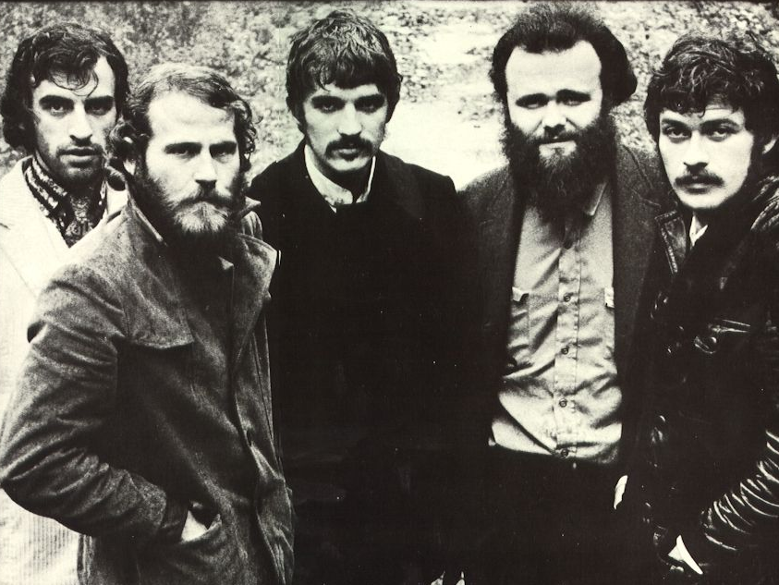

ARTIST INFORMATION

ANSWER KEY

“Did You Catch It?”

- gypsy, driftwood, cast away
- “livin’ south of the border” (reference to Louisiana)
- motherland (France), never parted (Atlantic Canada), and headed south (Louisiana)

“Did You Get It?”

- 7 Years’ War (this is an ERROR… it was actually over 1763, (Treaty of Paris))
- Louisiana
- Treaty of Paris, 1763. Signed by England and France.
- The people along the northeast coast of the US did not want Acadians settling along their land
- The Battle on the Plains of Abraham occurred September 13, 1759, well after the bulk of the Acadians had been deported.
- France
- Answers will vary
- Acadians are seen as the enemy. They were viewed as the enemy simply because they were French. In a way, both the English and the French saw them as the enemy. They really wanted to remain neutral during the war, but ended up being victims of circumstance.

ADDITIONAL RESOURCES

FROM SALRC:
VA5856 The Acadians
VA5777 Canada: A People’s History, Episode 03
VA7337 Expulsion: The Story of Acadia
VA4954 Origins: A History of Canada 12: Fall of New France

Originally rising to prominence as Bob Dylan's backing group, the quintet known simply as The Band later emerged as one of rock music's most seminal acts. In the late 60’s, their highly literate songs probed the mythology of the American experience (the great irony of their work, given the Canadian origins of all but one of their members). The Band had great success with songs like "The Weight","The Night They Drove Old Dixie Down", and "Up on Cripple Creek".

